M5Stack Tab5 Energy Monitor
by Bryan A. “CrazyUncleBurton” Thompson
Last Updated 2/28/2026

Sensor
Adafruit INA3221 Triple Current / Voltage Sensor

Connections
- Connect the USB C Cable – USB C on the Tab5 end and whatever type will plug into your computer on the other end.
- Connect the 4 pin plug end of the sensor cable to red port on M5Stack Tab5.
- Connect the 4 wire Grove to Dupont connector cable to the pins on the INA3221 sensor:

Sensor | Cable/Port
VCC | Red/VCC
GND | GND
SDA | Yellow/SDA
SCL | White/SCL

The Platform IO Project
The Platform IO project is located here: https://github.com/CrazyUncleBurton/M5Stack-Tab5-Energy-Monitor

Opening an Existing Project in VS Code
- Configure your machine per the documentation in “VS Code and Source Control.pdf” in the same folder as this documentation.
- Close all folders and projects in VS Code. File/Close Folder or File/Close Workspace will accomplish this.
- Browse to the GitHub project you want to clone: https://github.com/CrazyUncleBurton/M5Stack-Tab5-Energy-Monitor
- To clone the repository click the green Code button and press the copy icon next to the URL to copy the URL to the clipboard.
- Go to VS Code and click the Platform IO alien logo in the left toolbar and choose Clone Git Project from the Quick Access pane.
- In the window that opens at the top center of VS Code, press CTRL-V to paste the URL of the project and then press ENTER
- A dialog opens asking where on the local machine to put the folder that contains the project. It’s asking what folder it should put the folder that contains the local copy of the project. The answer to this question is always the folder
User Documents\PlatformIO\Projects
- Highlight the Projects folder, don’t browse into that folder
- Click Select as Repository Destination folder
- If you don’t have cached credentials for GitHub, you will be prompted to authenticate with your GitHub credentials:

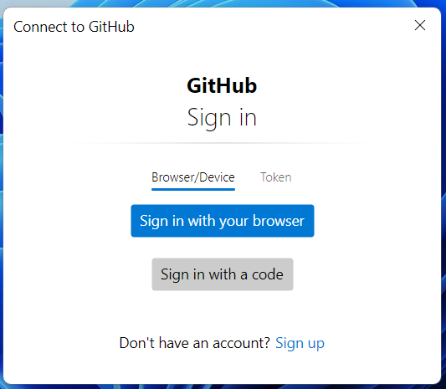

- Click Sign in with your browser
- This window will pop up saying Authentication Succeeded:



- The project will be downloaded to the local machine and open in VS Code.
- Platform IO will download the managed libraries and install a compiler for this CPU type. This may take some time, and looks like this:

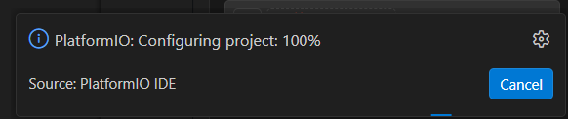

- Wait for all tasks to complete before proceeding!

Testing the Application
- Connect a USB cable from the computer that VS Code is running on to the M5Stack microcontroller.
- If the microcontroller is not on, press the white button on the side once to turn it on.
- In VS Code, click the Platform IO Upload icon in the bottom toolbar. The hover text will be Platform IO: Upload.
- The project will compile. When it’s ready to upload, we see lines like “Connecting…” and “Writing…”. Wait for the line that says SUCCESS in green text before proceeding.
- When finished, the microcontroller will reboot.
- When the microcontroller reboots, watch the display. You should see text that says “CrazyUncleBurton.com Energy Monitor” and a graph of live data.

Reference

M5Stack Tab5 Dev Board Info
https://docs.m5stack.com/en/core/Tab5

Microcontroller Info
https://www.espressif.com/en/products/socs/esp32-p4

https://www.espressif.com/en/support/documents/technical-documents?keys=&field_type_tid_parent=esp32P4Series-SoCs&field_type_tid%5B%5D=1633

Adafruit INA3221 Sensor Board Info
https://learn.adafruit.com/adafruit-ina3221-breakout

Texas Instruments INA3221 Sensor Data Sheet
https://www.ti.com/lit/ds/symlink/ina3221.pdf

M5GFX Display Library
https://docs.m5stack.com/en/arduino/m5gfx/m5gfx_functions

LVGL
https://lvgl.io/

LVGL Demo Project
https://github.com/nikthefix/M5Stack_Tab5_Arduino_Basic_LVGL_Demo

SquareLine Studios UI Creator (we need v8.33-8.4)
https://squareline.io/downloads

